ABAP

Mini Project

Indian Tourism

Document Control

Group - 2

This mini project is one of the modules created for Indian tourism using ABAP on SAP.

This module is for login, user details update, booking details update by the user and see the details of plans.

Table of Content

1. Assumption

2. Flow logic

3. Tables Created

4. Welcome Screen

5. User login Screen

6. Holiday spot details screen with adobe form

7. User details update screen

8. Booking details OOALV screen

9. Booking detail update screen

10. Printing Invoice

**1. Assumption**

* User table is already created.
* User already booked some plans.
* User wants to update profile details or user wants to update booking details or see the details of places he wants to plan on visiting.
* Booking of plans is done in separate module.

**2. Flow Logic**

**3. Tables**

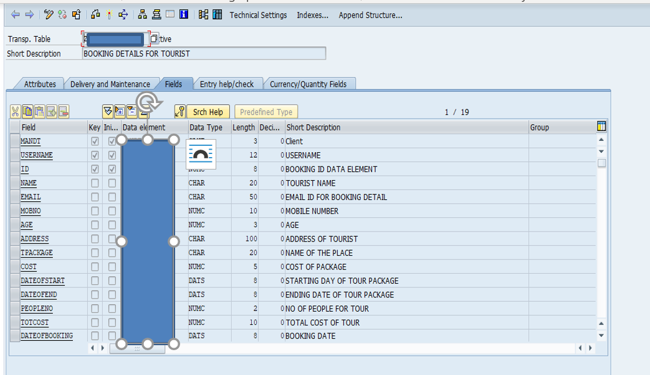

* I created a booking details table for saving details of booking.

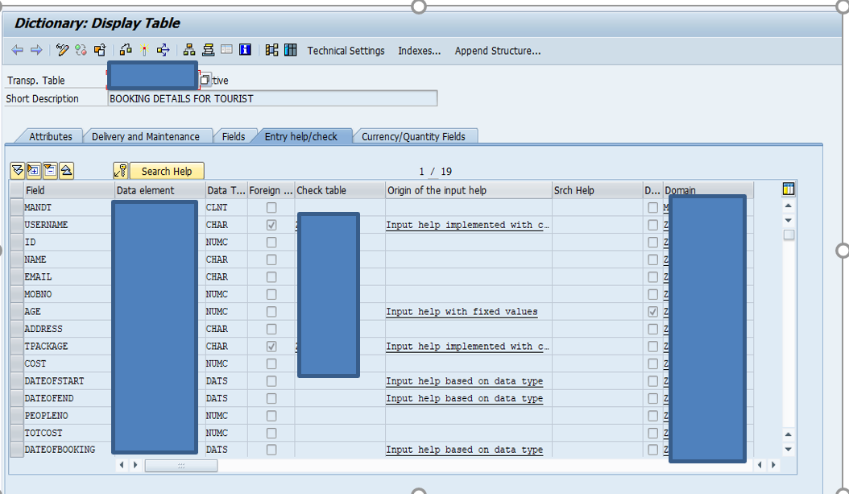

* Foreign key relationship with user data table and plans table on username field and tpackage field respectably.

**4. Welcome Screen**

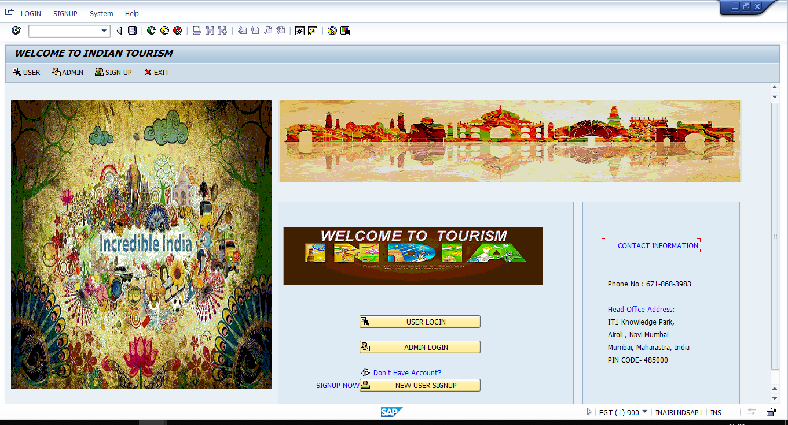

This Screen is welcome screen for Indian tourism project

From here we can go –

User Login screen by Clicking USER_LOGIN Button

Admin Login screen by clicking on ADMIN_LOGIN Button

User Signup screen by Clicking on NEW_USER_SIGNUP Button

**5. User login Screen**

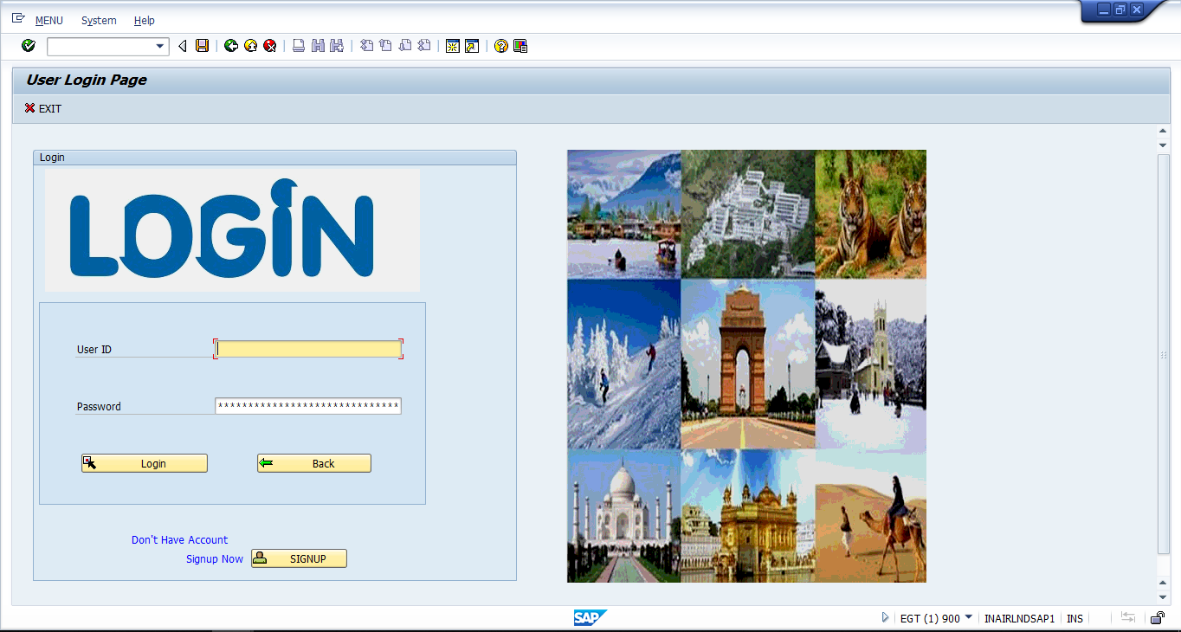

**Validation**: If user ID and Password do not match id and password from database it will show a message that ID or Password is wrong.

**Login –** if user ID and Password is correct it will logged in and take user to holiday spot screen

**Sign up** – it will take user to user signup page.

Back and exit will take user to welcome page screen.

Id – kgoyal

Password – kush@1234.

1. **Holiday Spot Screen with adobe form**

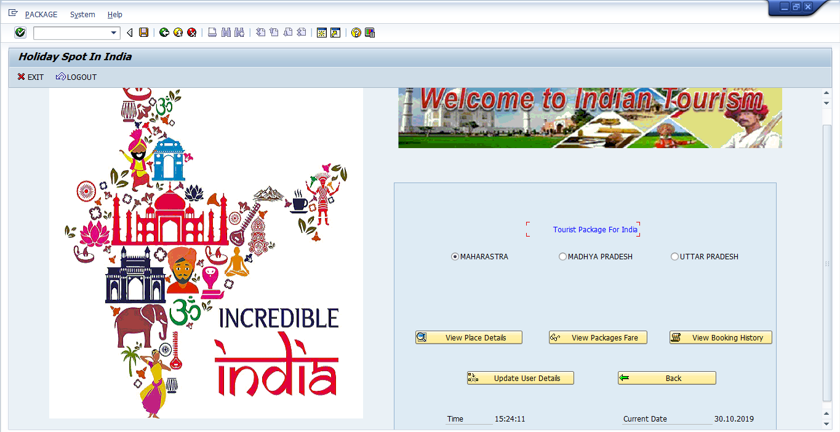

**View Booking History** – it will take user to booking details screen of particular user

**Update user details** – it will take user to profile update page.

**View package fare** – it will take user to see package details.

I give radio button for different state so when we click on

**View place details** – it will show adobe form for see details of place according to selected radio button

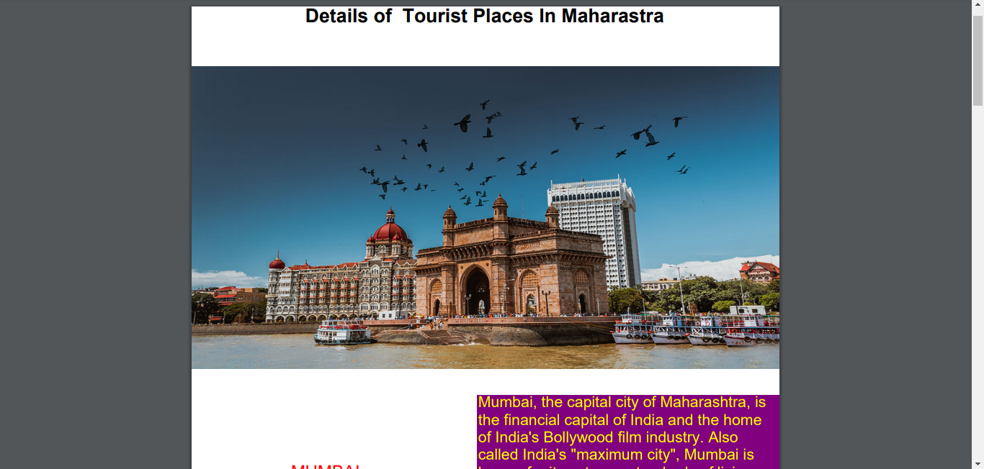

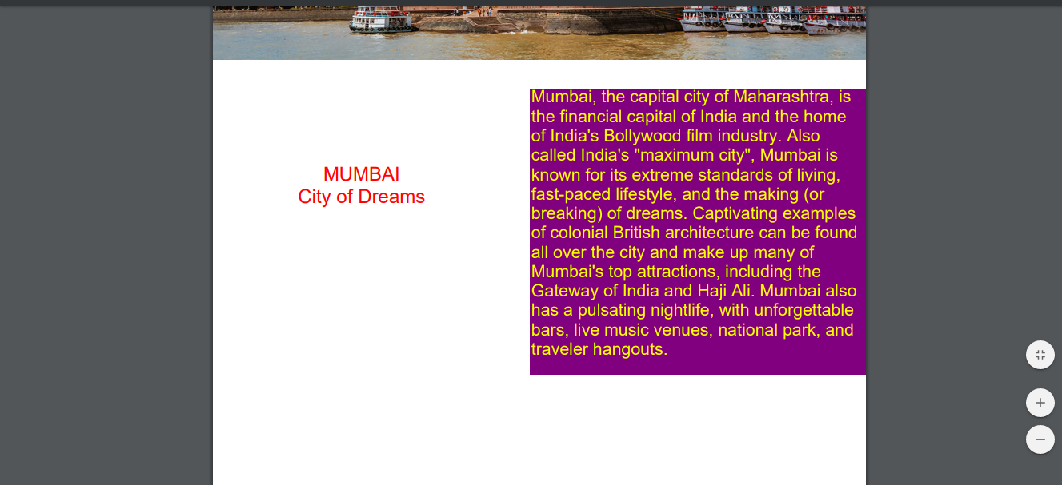

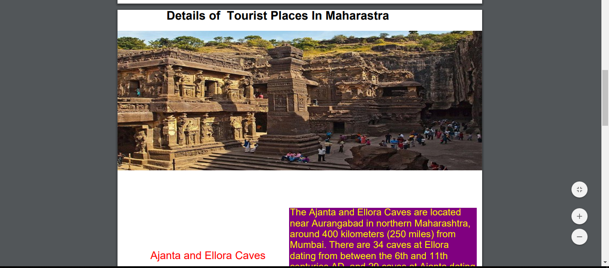

This is adobe form for radio button MaharashtraSo I made 3 different adobe forms for different state.

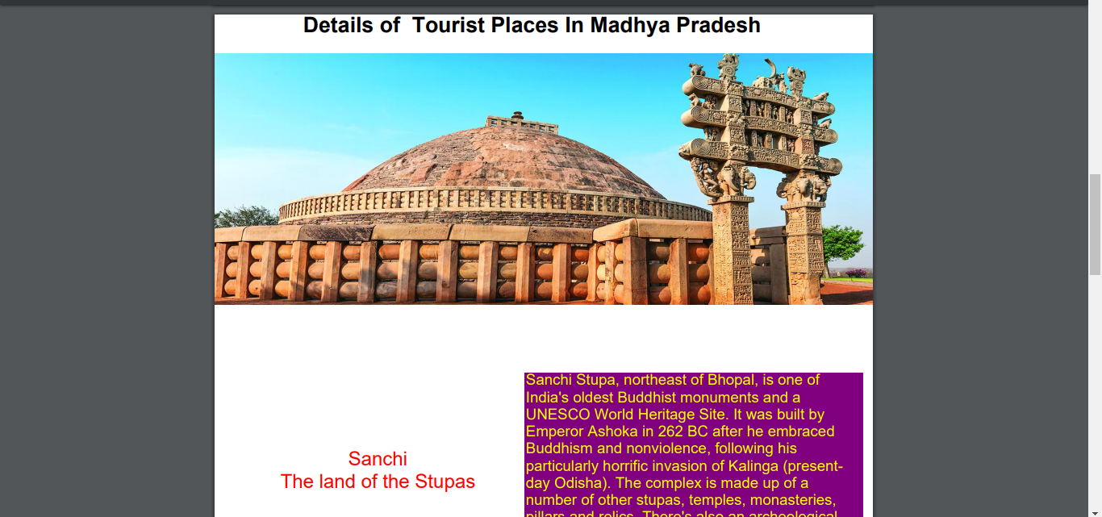

This are some screen shot of adobe form

**7. User Details Update Screen**

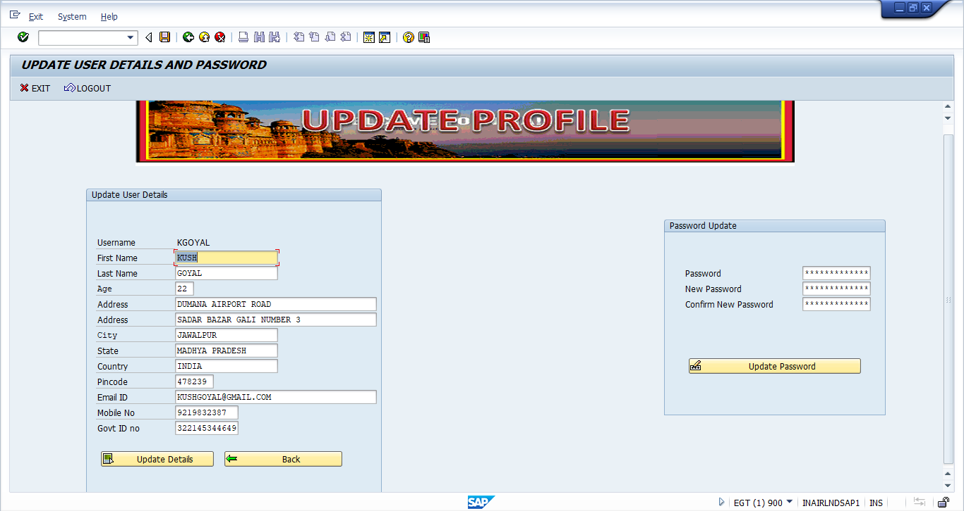

This will show details of logged in user from here user can update his details and password

**Validation:**

* Mobile no should be length of 10 digits and cannot have leading 0.
* Govt ID no should be length of 12 digit
* First name, email id, mobile no and govt id is mandatory fields.
* Old password cannot be wrong for password update.
* New password and old password cannot be empty and same.
* New password should equal to new confirm password.

**Update Details**: it will update details of user with message.

**Update password:** it will update password.

1. **Booking Details OOALV Screen**

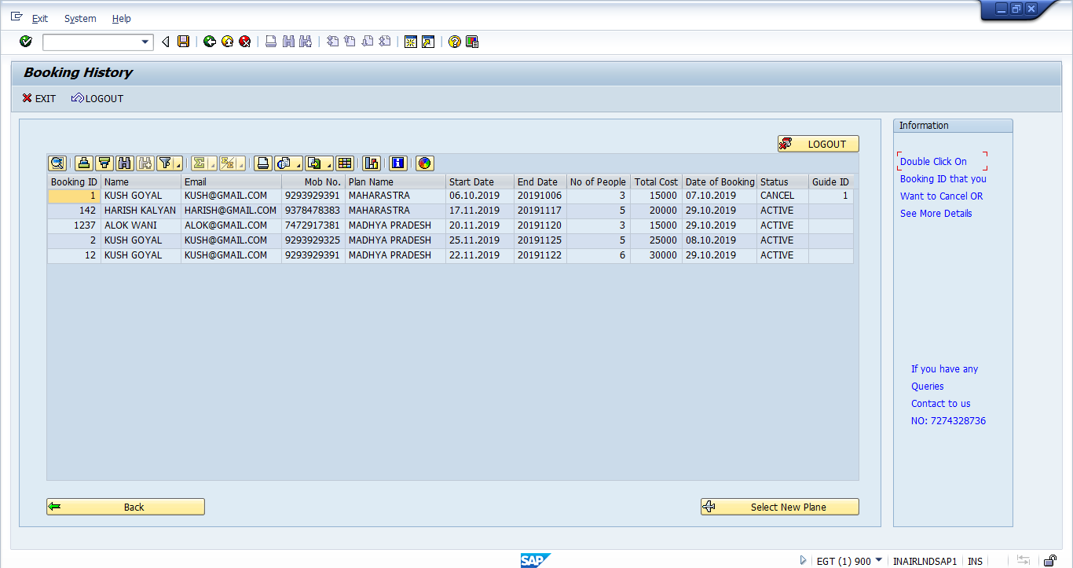

Here we can see details of booking by this user

By **double clicking** on any booking id it will take user to booking details update screen and after updating we can see updated OOALV.

9. Booking detail update screen

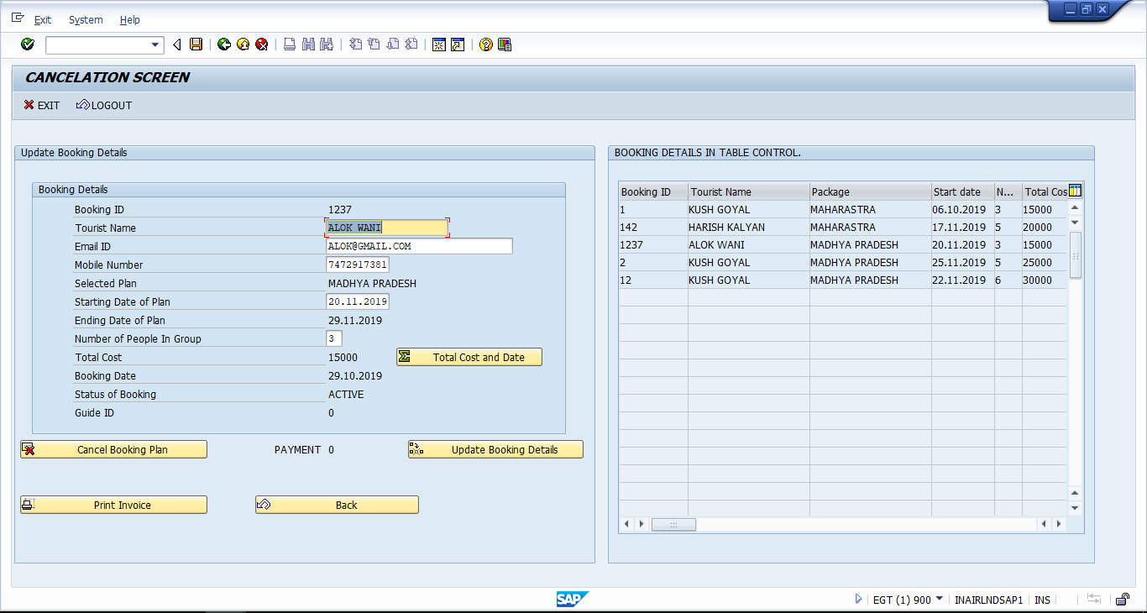

On this screen we can update details of booked ticket and see them on table control.

Validation:

* Mobile no should be length of 10.
* Start date cannot set less than updating date.
* User can’t update details if status is cancel or complete or in process.
* User can’t cancel booking if status is already cancel or complete or in process.

**Cancel Booking Plan** – it will cancel booking and change status to cancel.

**Total cost and data**- it will show how much user has to pay or user get to add in his account and if date is changed then change the end date also.

**Update Booking details** – update booking details.

**Print Invoice** – it will print invoice.

**10. Printing Invoice**

